Part ONE
- Use the windows snapshot program to capture a picture of the topology with these lights green. Paste it into your report.
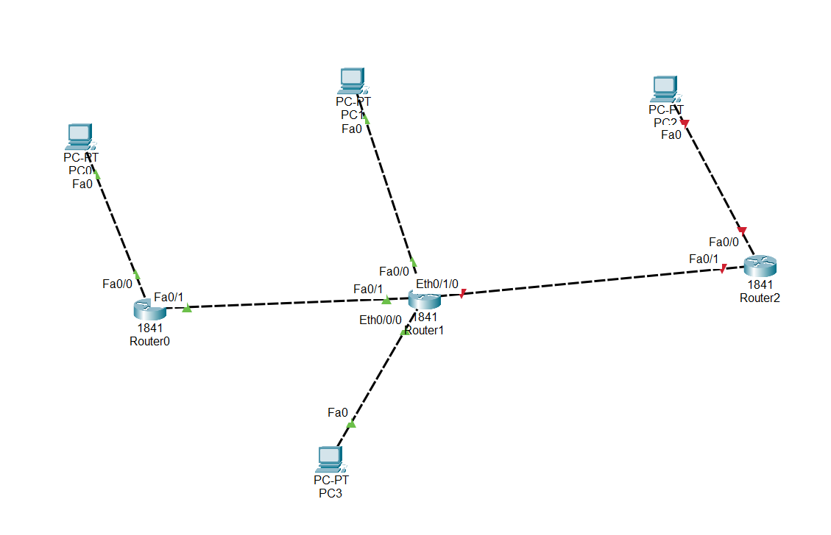
ii) On PC0 ping 131.44.38.14 (router 0). It should return a correct response. Cut and paste a picture of the ping command into your report.
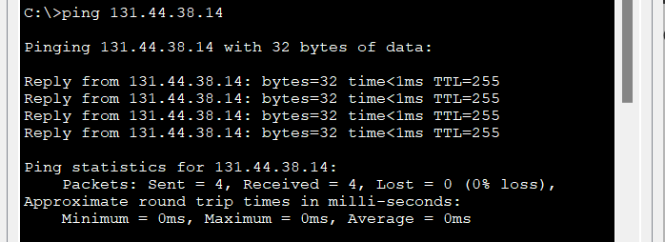
C:\>ping 131.44.38.14

Pinging 131.44.38.14 with 32 bytes of data:

Reply from 131.44.38.14: bytes=32 time<1ms TTL=255
Reply from 131.44.38.14: bytes=32 time<1ms TTL=255
Reply from 131.44.38.14: bytes=32 time<1ms TTL=255
Reply from 131.44.38.14: bytes=32 time<1ms TTL=255

Ping statistics for 131.44.38.14:
Packets: Sent = 4, Received = 4, Lost = 0 (0% loss),
Approximate round trip times in milli-seconds:
Minimum = 0ms, Maximum = 0ms, Average = 0ms

iii) On PC0 ping 193.35.16.15 (PC1) (there is a mistake and I change the IP address of PC1 by myself). It should return a correct response. Cut and paste a picture of the ping command into your report.
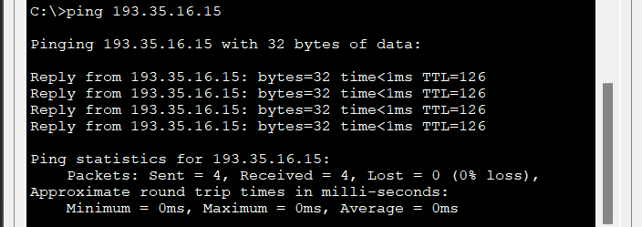
C:\>ping 193.35.16.15

Pinging 193.35.16.15 with 32 bytes of data:

Reply from 193.35.16.15: bytes=32 time<1ms TTL=126
Reply from 193.35.16.15: bytes=32 time<1ms TTL=126
Reply from 193.35.16.15: bytes=32 time<1ms TTL=126
Reply from 193.35.16.15: bytes=32 time<1ms TTL=126

Ping statistics for 193.35.16.15:
Packets: Sent = 4, Received = 4, Lost = 0 (0% loss),
Approximate round trip times in milli-seconds:
Minimum = 0ms, Maximum = 0ms, Average = 0ms

iv) On PC1 ping 193.35.16.16 (router1). It should return a correct response. Cut and paste a picture of the ping command into your report.
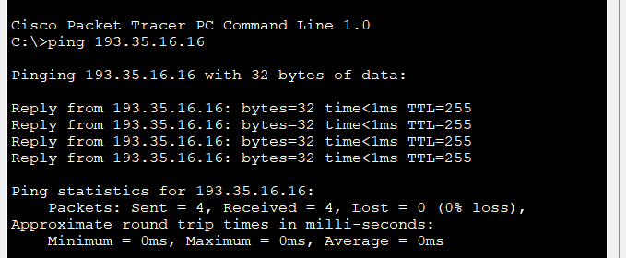
C:\>ping 193.35.16.16

Pinging 193.35.16.16 with 32 bytes of data:

Reply from 193.35.16.16: bytes=32 time<1ms TTL=255
Reply from 193.35.16.16: bytes=32 time<1ms TTL=255
Reply from 193.35.16.16: bytes=32 time<1ms TTL=255
Reply from 193.35.16.16: bytes=32 time<1ms TTL=255

Ping statistics for 193.35.16.16:
Packets: Sent = 4, Received = 4, Lost = 0 (0% loss),
Approximate round trip times in milli-seconds:
Minimum = 0ms, Maximum = 0ms, Average = 0ms

v) On PC3 ping 131.44.38.13 (PC 0). It should return a correct response. Cut and paste a picture of the ping command into your report.
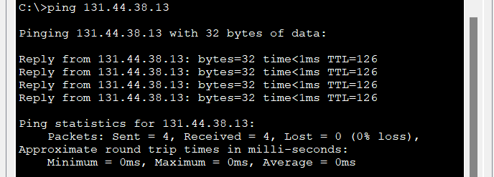
C:\>ping 131.44.38.13

Pinging 131.44.38.13 with 32 bytes of data:

Reply from 131.44.38.13: bytes=32 time<1ms TTL=126
Reply from 131.44.38.13: bytes=32 time<1ms TTL=126
Reply from 131.44.38.13: bytes=32 time<1ms TTL=126
Reply from 131.44.38.13: bytes=32 time<1ms TTL=126

Ping statistics for 131.44.38.13:
Packets: Sent = 4, Received = 4, Lost = 0 (0% loss),
Approximate round trip times in milli-seconds:
Minimum = 0ms, Maximum = 0ms, Average = 0ms

vi) On PC0 tracert 193.35.16.15 (PC1) (there is a mistake and I change the IP address of PC1 by myself). It should return a number of correct responses. Cut and paste the TEXT (not a picture) into your report.
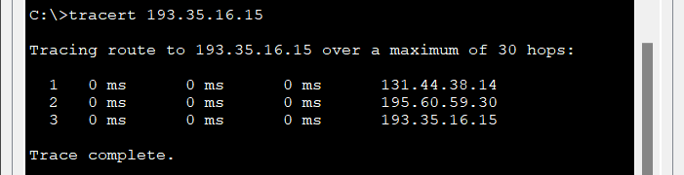
C:\>tracert 193.35.16.15

Tracing route to 193.35.16.15 over a maximum of 30 hops:

1 0 ms 0 ms 0 ms 131.44.38.14
2 0 ms 0 ms 0 ms 195.60.59.30
3 0 ms 0 ms 0 ms 193.35.16.15

Trace complete.

vii) On PC3 tracert 131.44.38.13 (PC0). It should return a number of correct responses. Cut and paste the TEXT (not a picture) into your report.
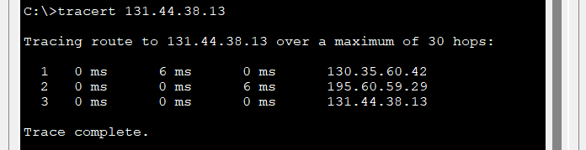
C:\>tracert 131.44.38.13

Tracing route to 131.44.38.13 over a maximum of 30 hops:

1 0 ms 6 ms 0 ms 130.35.60.42
2 0 ms 0 ms 6 ms 195.60.59.29
3 0 ms 0 ms 0 ms 131.44.38.13

Trace complete.

Part TWO
i) Use the windows snapshot program to capture a picture of the topology now. Paste it into your report.
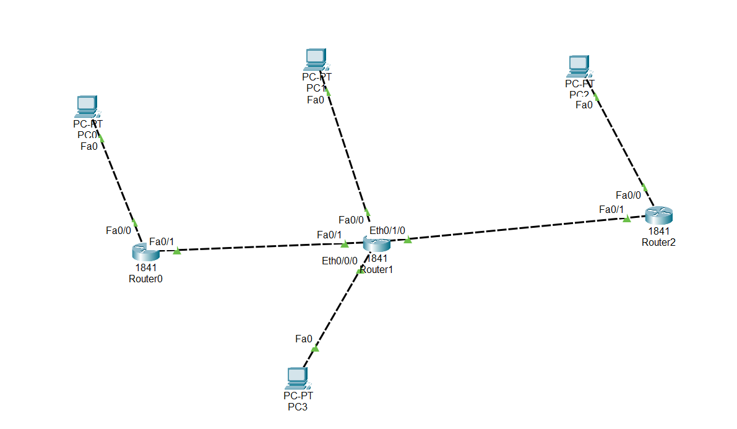
ii) Put into your report the new IP addresses and netmasks you used for each router making clear which interface is associated with each.
Device Interface IP address Netmask
Router1 Eth0/1/0 192.15.29.12 255.255.255.0
Router2 Fa0/1 192.15.29.13 255.255.255.0
Router2 Fa0/0 162.48.25.7 255.255.0.0
PC2 Fa0 162.48.25.6 255.255.0.0
PC2 Gateway 162.48.25.7 255.255.0.0

iii) On PC2 ping 131.44.38.13 (PC0). It should return a number of correct responses. Cut and paste a picture of the ping command into your report.
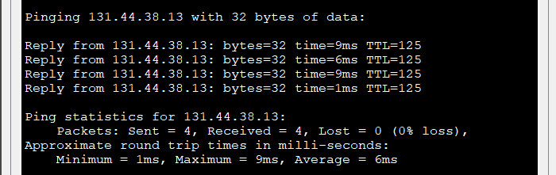
C:\>ping 131.44.38.13

Pinging 131.44.38.13 with 32 bytes of data:

Reply from 131.44.38.13: bytes=32 time=9ms TTL=125
Reply from 131.44.38.13: bytes=32 time=6ms TTL=125
Reply from 131.44.38.13: bytes=32 time=9ms TTL=125
Reply from 131.44.38.13: bytes=32 time=1ms TTL=125

Ping statistics for 131.44.38.13:
Packets: Sent = 4, Received = 4, Lost = 0 (0% loss),
Approximate round trip times in milli-seconds:
Minimum = 1ms, Maximum = 9ms, Average = 6ms

iv) On PC2 tracert 131.44.38.13 (PC0). It should return a number of correct responses. Cut and paste the TEXT (not a picture) into your report.
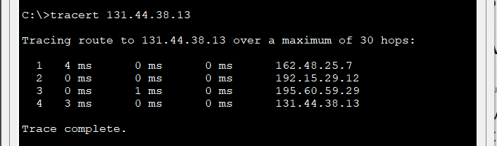
C:\>tracert 131.44.38.13

Tracing route to 131.44.38.13 over a maximum of 30 hops:

1 4 ms 0 ms 0 ms 162.48.25.7
2 0 ms 0 ms 0 ms 192.15.29.12
3 0 ms 1 ms 0 ms 195.60.59.29
4 3 ms 0 ms 0 ms 131.44.38.13

Trace complete.

